

National College of Ireland

Project Submission Sheet – 2020/2021

Student Name: | Aanchal Singh, Deepak Kumar Swain, Sai Prasanna Gontyala and Sweta Kumari  ………………………………………………………………………………………………………………
Student ID: | 19221771, 19216769, 19233388 and 19240848  ………………………………………………………………………………………………………………
Programme: | MSc. Data Analytics  ……………………………………………………………… | Year: | 2020  ………………………
Module: | Business Intelligence & Business Analytics  ………………………………………………………………………………………………………………
Lecturer: | Vikas Sahni  ………………………………………………………………………………………………………………
Submission Due Date: | 20-12-2020  ………………………………………………………………………………………………………………
Project Title: | Business Analytics for Netflix – Implementation  ………………………………………………………………………………………………………………
Word Count: | 3056  ………………………………………………………………………………………………………………

I hereby certify that the information contained in this (my submission) is information pertaining to research I conducted for this project. All information other than my own contribution will be fully referenced and listed in the relevant bibliography section at the rear of the project.
ALL internet material must be referenced in the references section. Students are encouraged to use the Harvard Referencing Standard supplied by the Library. To use other author's written or electronic work is illegal (plagiarism) and may result in disciplinary action. Students may be required to undergo a viva (oral examination) if there is suspicion about the validity of their submitted work.

Signature: | Aanchal Singh, Deepak Kumar Swain, Sai Prasanna Gontyala and Sweta Kumari  ………………………………………………………………………………………………………………
Date: | 20-12-2020  ………………………………………………………………………………………………………………

PLEASE READ THE FOLLOWING INSTRUCTIONS:

1. Please attach a completed copy of this sheet to each project (including multiple copies).
2. Projects should be submitted to your Programme Coordinator.
3. You must ensure that you retain a HARD COPY of ALL projects, both for your own reference and in case a project is lost or mislaid. It is not sufficient to keep a copy on computer. Please do not bind projects or place in covers unless specifically requested.
4. You must ensure that all projects are submitted to your Programme Coordinator on or before the required submission date. Late submissions will incur penalties.
5. All projects must be submitted and passed in order to successfully complete the year. Any project/assignment not submitted will be marked as a fail.

Office Use Only
Signature:
Date:
Penalty Applied (if applicable):

Business Analysis for OTT Platform- Netflix

Deepak Kumar Swain
MSc Data Analytics
National College of Ireland
Dublin, Ireland
x19216769@student.ncirl.ie
Sweta Kumari
MSc Data Analytics
National College of Ireland
Dublin, Ireland
x19240848@student.ncirl.ie
Aanchal Singh
MSc Data Analytics
National College of Ireland
Dublin, Ireland
x19221771@student.ncirl.ie
Sai Prasanna Gontyala
MSc Data Analytics
National College of Ireland
Dublin, Ireland
x19233388@student.ncirl.ie

Abstract—In order to understand the functioning and business of OTT platforms we chose our platform as Netflix. This report explains end to end implementation of Business process of Netflix. It takes into consideration Customer Relationship Management, Data preprocessing, data management through database, creating reports so that business can analyze the current business scenarios based on sales, shows, subscription, and work accordingly in order to improve business and increase subscription amount. This is an end-to-end enterprise solution.
Keywords—CRM, database, enterprise, business, analysis, reports

BALANCED SCORE CARD AND STRATEGIES
In order to understand the business performance, we need to have a measure. The balanced score card is one such measure which helps in being aligned with different strategies, initiatives and key performance indicators (KPI) [1][2]. It not only helps in keeping a track of different financial processes but also helps in creating new business and generating money [5]. There are four main characteristics of Balance Score card. These are as below:
- Financial
- Customer
- Internal Business Process
- Learning and growth
These characteristics have their own needs which are to be fulfilled. To name a few these can be defined as below:
- Objective: Setting strategies to achieve targets for the Company
- Measures: Keep track of various parametric by using KPI
- Targets: These can be short term, long term or mid-term goals.
- Initiative: You can divide the strategies created in objective so that these are achievable tasks.
Keeping these points in mind, a balance scorecard was created for Netflix which was curated for different strategies which help in increasing finances, satisfying customers so that they get more of what they need, internally checking for improvements in the organization and learnings which will help Netflix perform better.

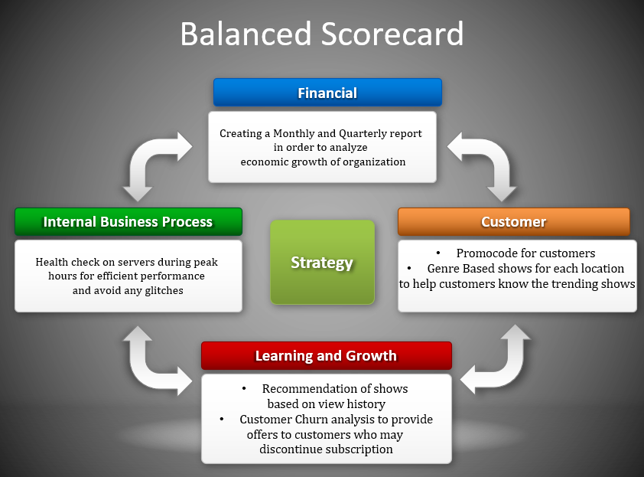
Figure 1: Balanced Score Card for Netflix
The Balanced Scorecard for Netflix covers the four aspects for the organization. The financial aspect here checks the monthly and quarterly sales or subscriptions taken by customer. This will help in keeping a check on economic growth of organization. The Customer aspect helps in giving the customer a better experience by showing relevant information for every customer. The learning and growth aspect will help Netflix improve their customer base and bring down the possible attrition rate. The internal Business process is a continuous process of improving the organization internally which will help in providing better efficiency for customers and reduce overheads for the employees.
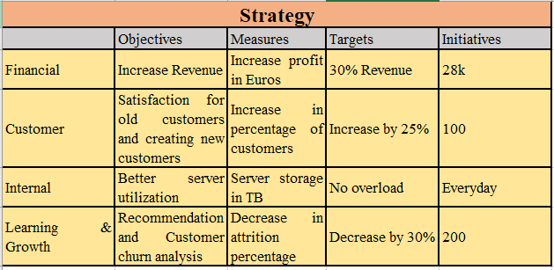 Figure 2: Strategies for Netflix

SOLUTION DEVELOPMENT PROCESS

Generating Data
In order to do an analysis for the entire business of Netflix we need to have relevant data of their customer base. Along with this we will need data about the regions in which they have a spread, their subscription plans and the shows present on the OTT platform. To create data, we have used random data generator site Mockaroo, Kaggle and Microsoft excel which helped us in having enough data to implement the end to end business functionality of Netflix.
- Kaggle.com
Kaggle is a website which has data repository of many millions of records for different fields. We referred Kaggle to get data related to Netflix shows and different genres.
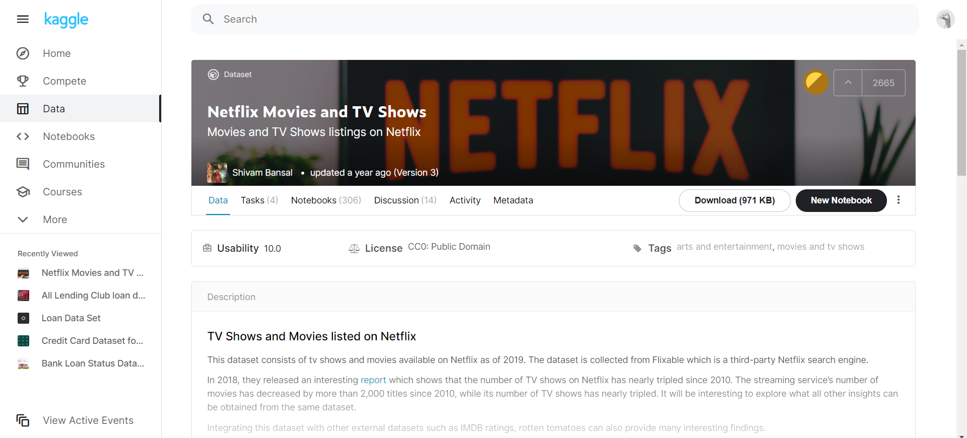
Figure 3: Data set from Kaggle
- Mockaroo.com
To get data related to customers we have used Mockaroo which helps in generating random customer records with their information like email, date of birth, gender, subscription start date, etc.
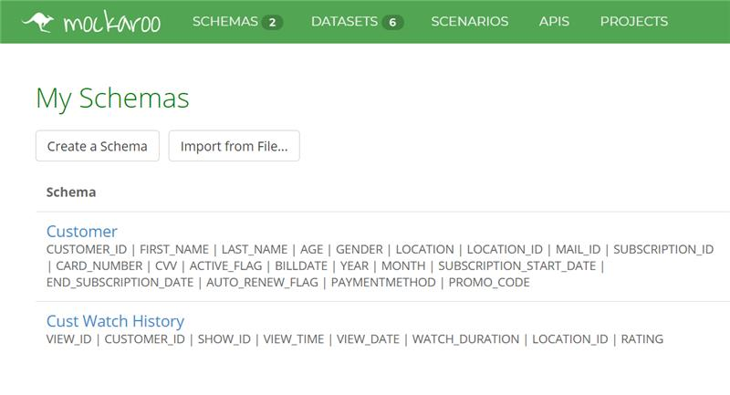
Figure 4: Customer and transaction details from Mockaroo
- Microsoft Excel
Using Microsoft Excel, we have generated data related to transactions and watch history of each customer.
We have created relevant data to show increased usage of Netflix during the pandemic. We have around 9 datasets for different categories which were cleaned using Microsoft Azure.

CONNECTIONS BETWEEN SERVICES
In order to establish connection between the data and manage it database is the perfect solution to it. Many companies provide database services which can be utilized in for the entire data of the organization. These companies include Google, Amazon Web Services, Microsoft Azure. The data we have is stored on Microsoft Azure and is migrated in two parts. First, we take the data to Microsoft Azure and then we move it to Power BI, that is we integrate Power BI with Azure and import the data to create final reports.
- Data Migration to Cloud
The Netflix data we have created need to be migrated to Azure. In order to migrate this data, we did the following steps:
1) We created a student subscription on Azure platform. In order to make this secure we have created resource groups which will provide access to only our group members. This provides access to only authenticated users.
2) After this, we created server with access to different tables. We have nine tables on this server. They hold the customer data, subscription information, genre data, data related to shows, transaction information and watch history of different customers.
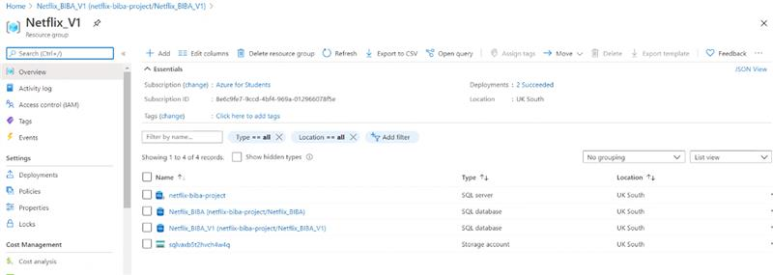
Figure 5: Azure server created where all data is stored in tables
3) The tables which are created on this server are as below having all data which is needed for Netflix.
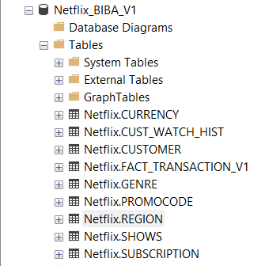
Figure 6: Tables created on SSMS through Azure server
For data integreity we have created different primary and foreign keys to establish unique and referential integrity. The TRANSACTION_V1 table is a table where all transaction data of customers is stored. It is used to check the activity of subcription renewals, payment methods, every payment done by customer in order to generate financial reports. Similarly we have created a table named CUST_WATCH_HIST which stores data of all shows watched by every customer, This table helps is keeping a check on trending shows, the duration a customer is watching Netflix which helps in maintaing the server health and also provide insights to improve customer satisfaction. For customer security purposes we have masked the data of customer contact details like number, credit card number and email details which helps in keeping customer information secure.
- Data loading from Azure to Power BI
Once the data is loaded in Azure we simply connect Microsft Azure to Power Bi by providing the server details created in Azure. By making the use of Get Data we connect these two and import the data which is ready for report creation.
- Provide the server details by choosing get data and then choosing SQL Server database option.
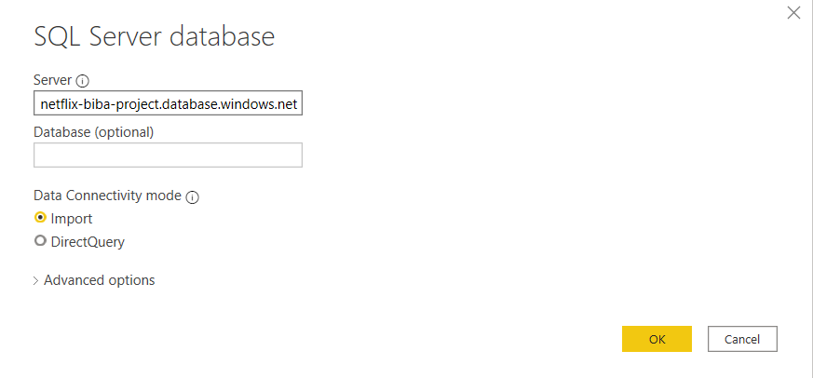
Figure 7: Power BI Get data by provide Azure server details
- We can provide the credentials for server and connect to the database. All tables can now be accessed from Power BI henceforth and data can be used to generate required reports.
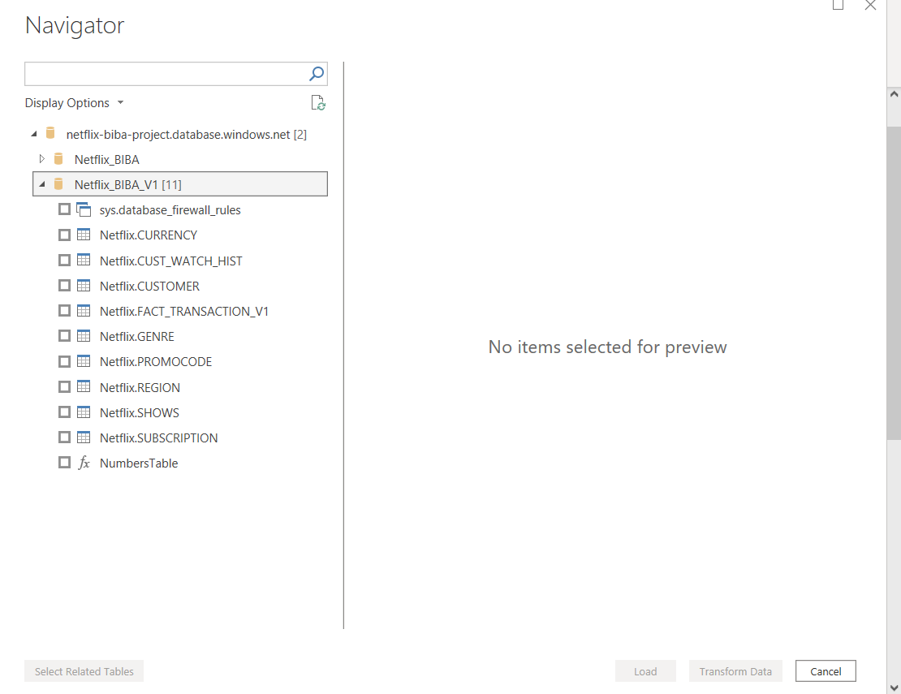

Figure 8: All tables can now be accessed from Power BI

IMPLEMENTATION OF SOLUTION
To implement a business solution, we need to have a complete enterprise system which consists of CRM [3] and business analysis reports. The CRM helps us in engaging with the customer and making him/her a client. Let us see the CRM for Netflix.

CUSTOMER RELATIONSHIP MANAGEMENT THROUGH DYNAMIC 365
Dynamic 365 is a software which helps us in maintaining the customer base. In this project we utilise this platform to increase sales and enhance marketing.
We maintain leads, opportunities and competitors through Dynamic 365. A step-by-step process to create lead into opportunity is explained.
- To create a lead, we go to ‘Sales Hub’
- Next in the left panel we click on Leads
- We can now create a new Lead and enter all details that are required. Click on save once all details are filled.

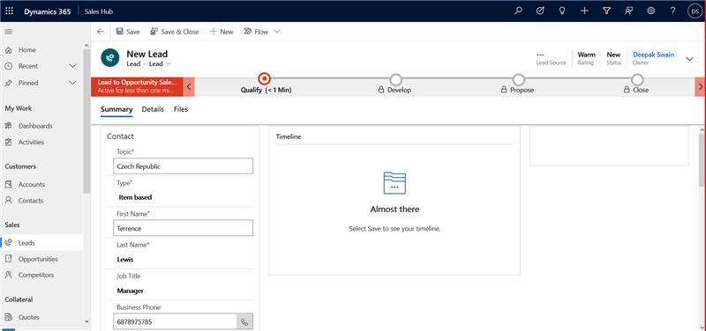
Figure 9: Lead creation

- Once we have a lead we can ‘Qualify’ the lead to change it to an opportunity. Click on the top panel of the page in order to qualify the customer.

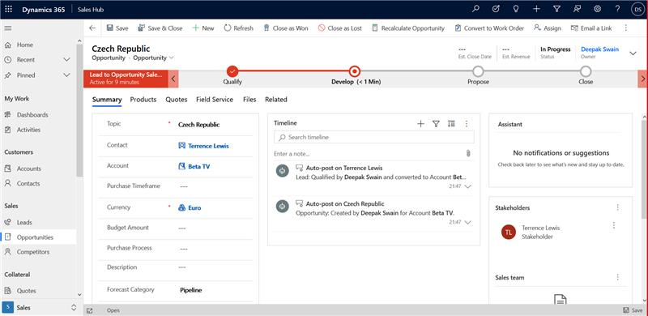
Figure 10: The lead qualifies as an opportunity

- Once the customer has qualified, we can check if the customer is won or lost. When we win a customer we put in the price for the bid and mark the customer as won.

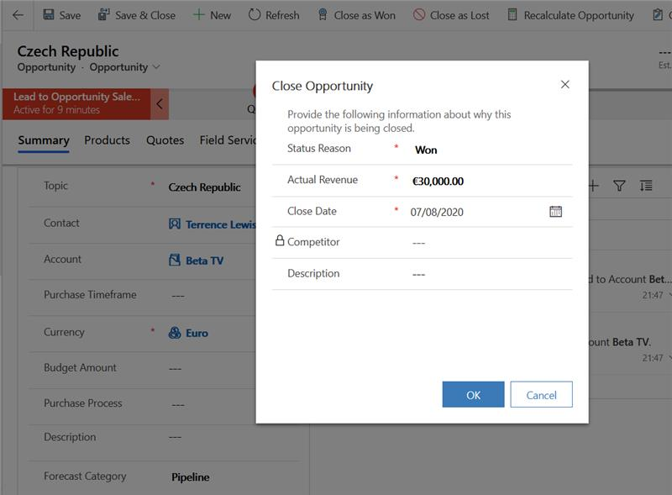
Figure 11: The lead is won successfully

- Once the lead is converted, we can assign this lead to our employees for better services to the customer.

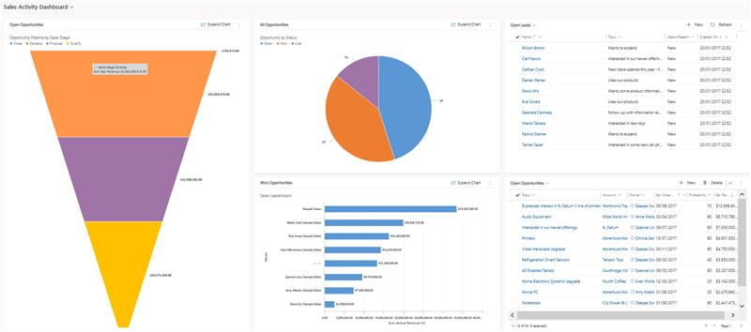
Figure 12: Funnel and pie chart for customers status and sales status

This diagram shows the number of customers who are won, lost and which are still open to be converted. We can also look for our competitors for Netflix for the customers where we lost our bids. These are Amazon Prime and Hotstar. The funnel diagram here shows us the opportunity pipeline by the Sales Stage. We have qualified customers where we propose our offers like different promocodes. These can be included for new customers and existing customers. Using promocodes as campaign we can win new customers and also retain customers who may unsubscribe.

BUSINESS ANALYSIS THROUGH DASHBOARDS USING POWER BI
Once all the data is aligned and CRM is setup, we can now have an in-detail analysis of the customers, their subscriptions, their watch history, and transaction history. This data is very helpful and will provide us with insightful information which will be useful for Netflix to improve and existing customer base and build a new customer base. The below dashboards are an example of analysis through data which is interactive, colourful and an efficient way of portraying the data we have.

Netflix Home
This is the main page of the reports. It has an interactive way of navigating to the different reports that we have created. The four dashboards can be accessed with a click of button by just clicking on the Dashboard names. The user can easily access any of these dashboards and the underlying reports.

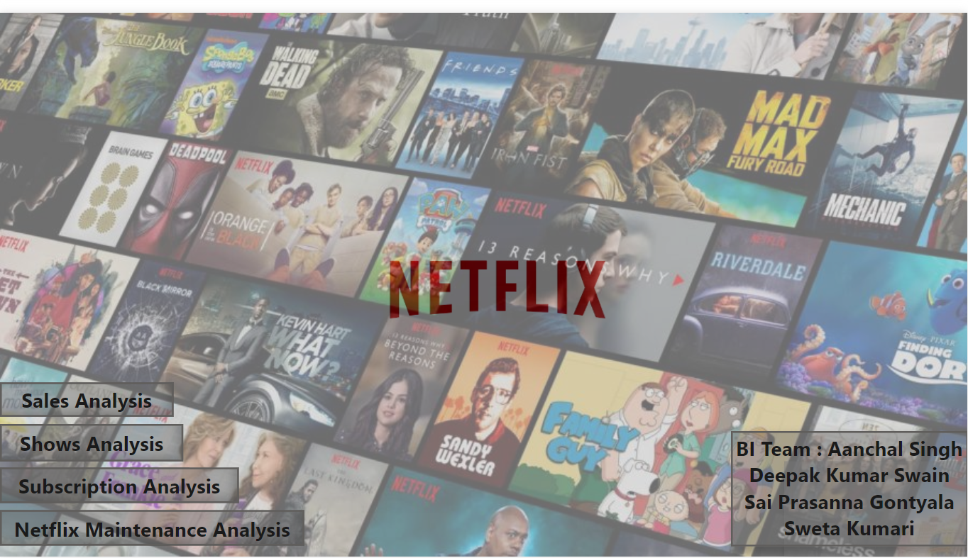
Figure 13: Netflix Home Page

Sales Analysis

The sales analysis report is a summary of the sales done by Netflix based on different parameters. The top row of dashboard has different filters on whose basis analysis can be customized. The country filter enables us to get country wise amount for different months and two years of 2019 and 2020. Similarly, this data can be filtered by Year, Month and Genre.

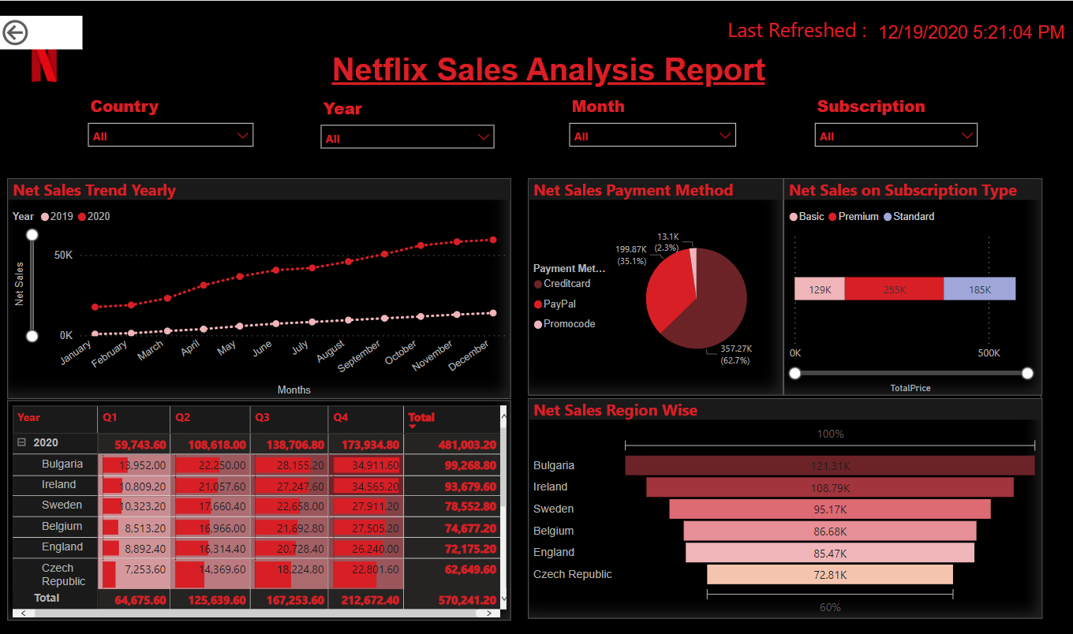
Figure14: Sales Analysis Report

The reports on the dashboard are:
- Net Sales Trend (Yearly)
The first report which is a line chart summarizes the data for two years for every month and displays the net subscription amount comparison that Netflix had for the years 2019 and 2020. The trend here shows that subscription amount has increased considerably in 2020. The reason here can be the pandemic as the entire Europe was in lockdown.
- Net Sales by Payment method
In order to get which payment methods are convenient for users we have created a pie chart where we can segregate these methods and provide user friendly payment options.

- Net Sales on Subscription type
This stacked bar chart is a summary of subscription amount on the basis of Subscription type chosen by customers. This can be Basic, Standard or Premium. It helps in checking which subscriptions are being used more.
- The fourth matrix is a summary of entire year based on subscription amount that Netflix obtained. It is divided in four quarters based on the different locations that we have. There is a considerable increase observed in amount as well between the two years.
- Net Sales Region Wise
The net subscription amount generated for the six countries is showed in the funnel report. It also shows the watch hours of all countries.

Shows Analysis Report
The show analysis report summarizes subscription data
With other important parameters. Subscription data is important, but which shows most watched with genre is most important for the analysis and it play pivotal role for future to grab customer and serve them with what they like and want. This report will drive us with in-depth analysis over shows selection by Netflix users based on country, Age, Shows watch history and View time hours on server maintenance.

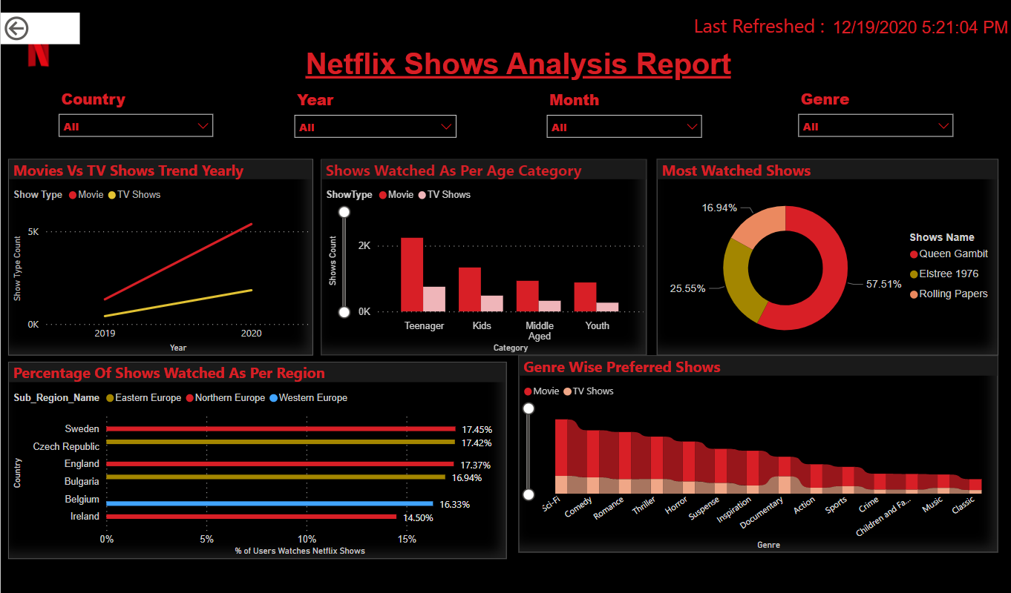 Figure15: Shows Analysis Report

- Movies Vs TV Shows trend (Yearly)
Here we are comparing shows selection by users for the year and we can infer users choose movies over TV Shows. This will help Netflix to focus more on Movie selection over TV Shows.
- Shows watched as per Age Category
This line chart is displaying all the shows which are watched by different groups of age. The ages are divided into different categories.
- Percentage of shows watched as per region
This clustered column chart is displaying the percentage of watch duration of the shows. All shows are taken and their duration for calculating percentage is displayed.
- Most Watched shows
Based on watch history of shows, the topmost shows which are being watched overall in six countries is being displayed. We have used a donut chart for this representation.
- Genre Wise preferred shows
There are different genres for shows and movies. We are displaying a percentage for each genre, based on the shows and customer watch history. This will help in analysing which genre is being watched the most.

Subscription Analysis Report
The Subscription analysis report has subscription data which helps in understanding how the different subscriptions are being analysed. Below are the reports which help us understand subscription data better.

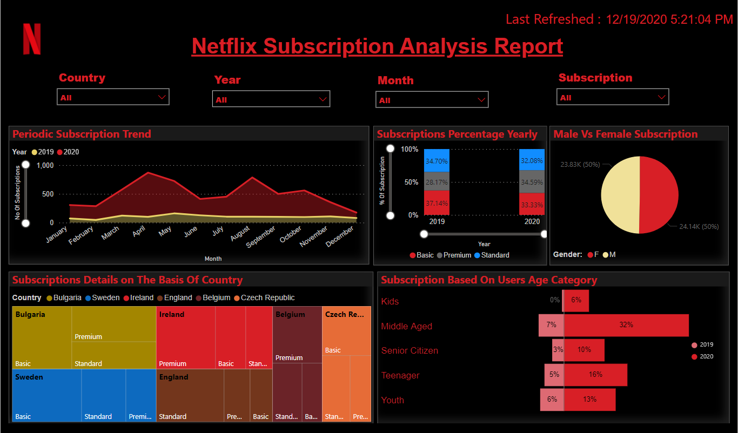
Figure16: Subscription Analysis Report

- Periodic Subscription Trend
For the period of two years, we have used the subscription start date along with the year. This shows how many new subscriptions were started during these two years. A comparison of these two years is visible on the stacked area chart.

- Yearly Subscription Percentage
In this stacked column chart a percentage of subscriptions based on subscription types for the two years is being displayed.
- Male Vs Female Subscription
This pie chart takes count of subscription based on the gender.
- Subscription details based on country
This report is taking different countries under consideration and checking the different types of subscription and on the basis of number of subscriptions for each subscription type and country a Tree map is created.
- Subscriptions based on User’s Age Categories
This Tornado graph displays different ages divided into categories and then checks the number of subscriptions considered for each category.

Netflix Maintenance Analysis Report
Customer relationship is an important factor for any organization. In order to improve customer base, we provide promocodes and also take ratings for different shows.

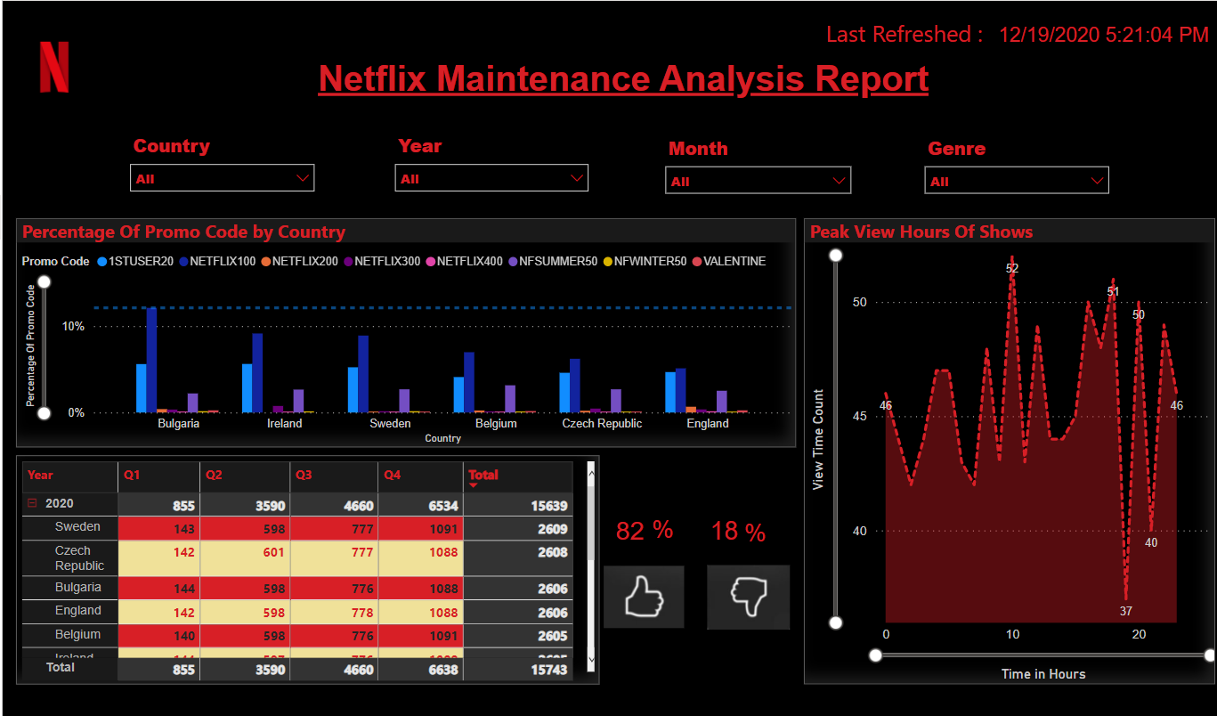

Figure17: Netflix Maintenance Analysis Report

- Promo Code Usage in countries
A percentage of promo codes used is as a parameter and which promocodes are being used more in which country is being displayed in this report.

- This is a matrix report where we are taking customers who are using auto renewal services for the six countries. We are using a quarterly report to show autorenewals for each quarter throughout the year.
- This visual helps us to determine the variance of peak hours when customers are using Netflix most on daily basis to help and maintain the health of server so that they are not overburdened and server usage can be optimized.
- Likes and Dislikes.
A caption is added for percentage of likes and dislikes of different shows in total.

BENEFITS OF SOLUTION
The year 2020 has become a catastrophe in all over the world which affected several areas. But it also created opportunities for some business. One of them is Over the top (OTT) platforms like Netflix. The focus for implementing this solution is to bring agility in organizational processes through faster and precise reporting, planning and analysis. The analysis is done on six key European countries (Ireland, Sweden, Belgium, Bulgaria, Czech Republic and England) for the years 2019 and 2020. This comparison gives an insight about several business areas based on sales, shows, subscription, promocodes, customer feedback.

As shown in the sales analysis dashboard (Figure 16), the sales trend goes up even if the usage of promocode is less for 2020. This infers that the customers have shown interest in subscription despite of low discounts. In this case, it helps the organization in the decision making to invest more on inventory and switch marketing strategy from distribution of promo codes to advertising the contents available on Netflix.

The ‘Shows Analysis Dashboard’ (Figure: 15) clearly shows that users are more into watching movies than TV shows. Also, it depicts the genre type which are mostly being watched. This will help the business to take a decision on what kind of shows need to be purchased or created to keep the customer’s interest.

The maintenance dashboard (Figure: 17) gives the information about the peak hours when servers are highly engaged. This will help the server maintenance team to handle the servers in an efficient manner through required load balancing between the clustered servers.

FUTURE ENHANCEMENT
This project gives insights about descriptive analysis. In future, following predictive analytics can be used to build stronger relationship with customers.

Unsupervised clustering machine learning algorithms can be used to analyse the type of shows are being watched by individual customers and in a particular region so that recommendations can be given to the users.

Supervised classification machine learning algorithm can be used for customer churn analysis which will help the business to understand which are the potential churning customers. This will help the company to provide offers to keep the customers with it.

CONCLUSION
By the implementation of Business analysis and intelligence for Netflix we were able to provide an insight for sales team where they can get region wise, customer wise and yearly reports to increase the sales.
The subscriptions data helps us understand the trends in increase of subscriptions between the two years and also helps us understand it by country, age and gender.
Maintenance report helps in getting feedbacks, ratings and server optimization insights.

REFERENCES
[1] E. Tarver, \Use a balanced scorecard to detect and prevent _rm
weaknesses," 2019.
[2] R. S. Kaplan and D. P. Norton, \The balanced score-
card|measures that drive performance," 08 2014.
[3] Enhancing Enterprise Intelligence, Leveraging ERP, CRM, SCM, PLM, BPM, and BI, Vivek Kale, page 109-140

